INTRODUCTION TO SOFTWARE ENGINEERING  Ruchita Shah | Chapter 1

Objectives
The objective of this chapter is to introduce concept of software engineering and related terms. When you will read this chapter you will :
- Understand what is software and types of software;
- Get insight of software engineering, process framework and umbrella activities;
- Gain knowledge about capability maturity model.

What is a software?
Computer software is the product that software engineers build. It encompasses programs, database, documents. Now a days computer software is included in majority of the products. It has become pervasive in commerce, culture and our everyday activities.
A textbook definition of software can be: software is (1) set of instructions (programs) that when executed provide desired feature, function and performance (2) data structure that allows program to adequately manipulate information and (3) documents that describes operations and use of programs.
Role of s/w
Software serves dual roles. It is a product as well as a means to produce a new product. As a product, it allows users to utilize computing potential of computer hardware. As a product, software transforms information through various processes. It acquires information from various input sources. It manages information by performing processes on it such as sorting. It produces information as a result of processes. It modifies information to the needs of users. It formats information for display. And it transmits information through network. These information can be a simple one bit of data or can be a complex like multimedia presentation. As a vehicle to deliver product, software controls hardware (operating system), controls communication of information over network, and allows to create & control other programs.
Software delivers most important product of our time, the information. It can transform personal data, manage business information to enhance competitiveness. It provides gateway to worldwide information networks. Role of computer software has changed tremendously over span of more than 60 years.
We have seen tremendous improvement in hardware performance and its computing architecture over the years. Size of its memory and storage devices has improved drastically. It offers variety of input and output devices. These all has resulted in a more sophisticated and complex computer-based system. But such tremendous changes are not seen in the ways software are being built and delivered. Many questions arise:
- Why does a software need longer time to finish?
- Why are software development costs so high?
- Why finding errors before delivering software to customers is still impossible?
- Why maintenance of existing software requires so much time and cost?
- Why we face difficulty in measuring software development and maintenance progress?
These questions has led to adoption of software engineering practices.

Types of software:
Information content & information determinacy determine type of software applications. Content refers to input & output data, determinacy refers to predictability of order & timing of information
System software : These are the programs that service other program such as operating system. some operating systems process complex & determinate info whereas some operating systems process indeterminate data. Characteristics of such operating systems are heavy interaction with hardware, multiple user, concurrent operations that require scheduling, resource sharing, process management, complex data structure, multiple external interface etc.
Application software : These are standalone programs that solve a specific business needs. Such applications facilitate business operations and decision making. Some software are also used to control real-time business functions for e.g. Point of sale transaction processing, real time manufacturing etc.
Engineering/scientific software : These software can be characterize as number crunching algorithms which range from astronomy to volcanology, from molecular biology to automated manufacturing. Some examples are : Computer Assisted Designing (CAD), weather forecasting systems etc.
Embedded software : these software reside within a product or system. They are used to implement control features for end users. They generally have limited functions.
Product-line software: Such software provide specific capability for use by many different customers. These software address mass consumer markets e.g. Word processor, Spreadsheets etc.
Web-applications: These are wide range of application stored as set of linked hypertext files. Nowadays webapps give sophisticated computation by integrating corporate databases & business applications.
Artificial Intelligence software : these software uses nonnumeric algorithm to solve complex problems that cannot be solved by computation. Applications include robotics, expert system, artificial neural network etc.
Ubiquitous computing software: Rapid growth of wireless networking has led to distributed computing. They pose challenge to software engineers to develop such systems that allow small devices and computers to communicate across vast network.
Net sourcing : World Wide Web has become a computing engine & content provider both. There is a need to provide simple & sophisticated applications that benefits targeted end-users worldwide.
open source software : A policy of distribution of source code for system applications to customers has made source codes available for local modifications. Software developers need to build self -descriptive source code along with techniques that allow users to know what changes have been made to the software.
The New Economy software : The dot-com economy lead to new applications that facilitate mass communication and mass product distribution.
Activity 1
Based on what you have learned so far categorize following software.
- Tally _____________________________
- Ubuntu _____________________________
- Java _____________________________
- Avionics system _____________________________
- Amzon.com _____________________________
- Online banking software _____________________________
- Robot system _____________________________

Software Engineering- A Layered Technology
There exists many definition for software engineering. Fritz Bauer proposed a definition :
“ Software Engineering is establishment & use of sound engineering principles in order to obtain economical software that is reliable & works efficiently on real machine”.
This definition provides baseline. IEEE developed a more comprehensive definition :
“ Software Engineering (1) is the application of a systematic, disciplined & quantifiable approach to the development, operation & maintenance of software; i.e. the application of engineering to software and (2) the study of approaches as in (1)
Software engineering is a layered technology. As shown in the figure, commitment to quality is provide bedrock to software engineering. An engineering approach must have a focus on quality which provides continuous process improvement culture.

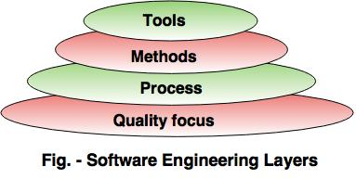
Process layer serves as foundation for software engineering. This layer holds technology layers together and enables timely & rational development. Process defines a framework with activities that are for effective delivery of software engineering technology. Process also forms basis for management to monitor and control of software projects.
Methods provide technical how to for building software. It encompasses many tasks including communication, requirement analysis, design modelling, program construction, testing & support.
Tools provide automated/semi-automated support for process and methods. It combines software, hardware & database to create software engineering environment.
A process Framework
Software process – To build any product, a series of predictable steps, a road map, are designed. It is called a process. Same applies to software. Software process helps achieve timely high quality result. It consists of a framework for tasks that are required to build high quality software.
A process framework creates the foundation for software process. It begins with identifying framework activities. These activities are applicable to all software projects. Framework also encompass a set of umbrella activities that are applicable across entire software process.

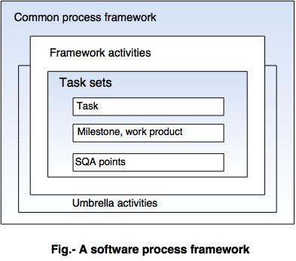
Each framework activity consist of a number of software engineering tasks that accomplishes some part of software. Majority of software follow generic process framework consisting of : communication, planning, modelling, construction and deployment.
Communication : Refers to communication and collaboration with customer for requirement gathering.
Planning : This activity refers to software engineering work plan to be followed. It deals with technical tasks, schedule, resources, risk associated with software, work products to be produced etc.
Modelling: It consists of analysis and design. Analysis creates analysis model. Design models is created from analysis model. Design model enables developer and customer to understand software requirements and if design will achieve it.
Construction : Refers to code generation and testing; either manually or automated.
Deployment : Completed software is delivered to customer who then evaluate it and provide feedback.
These five framework activities are applicable for the development of small project or a large and complex computer based systems alike.
Umbrella activities
All framework activities are surrounded by umbrella activities. Umbrella activities are applied throughout software project. If applied systematically, these activities ensure successful completion of project.

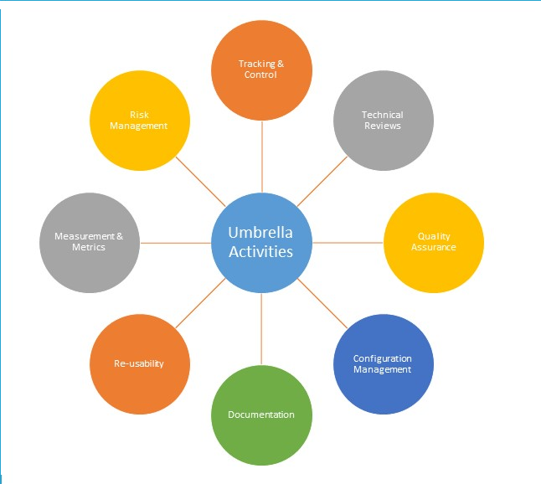
Fig. – Umbrella Activities

Tracking and Control – The developing team accesses project plan against predefined schedule. If they find that project is not going according to predefined schedule, necessary actions are taken to maintain the schedule.
Technical reviews - The aim of technical reviews are to detect quality problems and suggest improvements. The technical person focuses on the quality of the software from the customer point of view.
Quality assurance – Quality Assurance is conducted assess software quality. For example, during the software development meetings are conducted at every stage of development to find out the defects and suggest improvements to produce good quality software.
Configuration management - This activity manages the effect of change throughout the software process.
Documentation – This activities that are needed to create the documents, forms, lists, logs and user manuals for the software being developed.
Re-usability –This activity defines the specification for reuse of the products. It also set up a mechanism by which a reusable components are developed and used.
Measurement and metrics – Software can be measured directly and indirectly. Direct measures are line of code, cost etc. Indirect measures are quality, functionality etc. This activity defines how software can be measured and using which metrics. It also help develop new metrics for developer.
Risk management – Risk is an event that may or may not occur. Many risks are associated with any project. This activity assesses if risk may occur and if they occur how it will affect project.
Activity 2
- Which layers are there in software engineering?
______________________________________________________________
- What is the meaning of Modelling in process framework?
______________________________________________________________
- What is an umbrella activity?
______________________________________________________________
- Which umbrella activity is conducted when a developer want to use existing small program in new project? ___________________________________________

Capability Maturity Model Integration (CMMI)
The Capability Maturity Model Integration, or CMMI, is a process model that provides a clear definition of what an organization should do to promote behaviors that lead to improved performance. With five “Maturity Levels” the CMMI defines the most important elements that are required to build great products, or deliver great services, and wraps them all up in a comprehensive model.

CMM Examples:
People CMM: Develop, motivate and retain project talent.
Software CMM: Enhance a software focused development and maintenance capability.

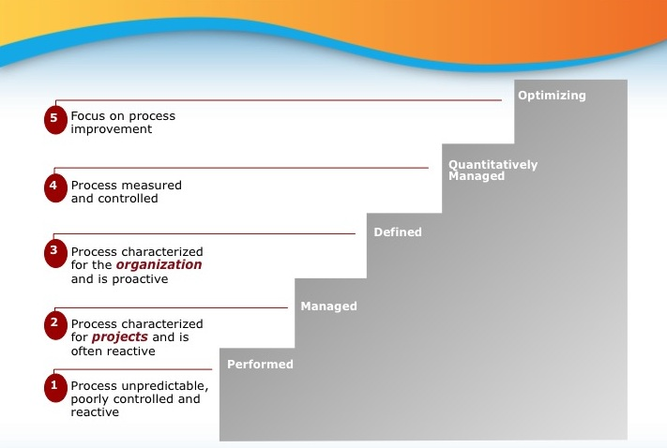
Fig.- Five maturity levels of CMMI
Maturity level 1- Performed : At this level, processes are usually ad hoc and chaotic. The organization usually does not provide a stable environment and do not use any proven processes. Such organizations often produce products and services that work; however, they frequently exceed the budget and schedule of their projects. Characteristics of such organizations are a tendency to over commit, abandon processes in the time of crisis, and not be able to repeat their past successes.
Maturity level 2 – Managed : At this level, an organization has achieved all the specific and generic goals of the maturity level 2 process areas. projects are performed and managed according to their documented plans. Organization ensures that project requirements are managed and that processes and work products are planned, performed, measured, and controlled. Work products are reviewed with stakeholders.
Maturity level 3 – Defined : At this level, processes are well characterized and understood, and are described in standards, procedures, tools, and methods. At maturity level 3, the standards, process descriptions, and procedures for a project are tailored from the organization's set of standard processes to suit a particular project or organizational unit. The organization's set of standard processes includes the processes addressed at maturity level 2 and maturity level 3. As a result, the processes that are performed across the organization are consistent except for the differences allowed by the tailoring guidelines. Processes are managed more proactively using an understanding of the interrelationships of the process activities and detailed measures of the process, its work products, and its services.
Maturity level 4 – Quantitatively managed : At maturity level 4 Sub-processes are selected that significantly contribute to overall process performance. These selected sub-processes are controlled using statistical and other quantitative techniques. Quantitative objectives for quality and process performance are established and used as criteria in managing processes. Quantitative objectives are based on the needs of the customer, end users, organization, and process implementers. Quality and process performance are understood in statistical terms and are managed throughout the life of the processes. For the processes, detailed measures of process performance are collected and statistically analyzed. Quality and process performance measures are incorporated into the organization’s measurement repository to support fact-based decision making in the future.
Maturity level 5 – Optimizing : At this level, processes are continually improved based on a quantitative understanding of the common causes of variation inherent in processes. Focus is on continually improving process performance through both incremental and innovative technological improvements. Through quantitative process improvements, changing business objectives are revised. Improvements in processes are measured and evaluated against the quantitative process-improvement objectives.
Optimizing processes that are agile and innovative depends on the participation of an empowered workforce aligned with the business values and objectives of the organization. The organization's ability to rapidly respond to changes and opportunities is enhanced by finding ways to accelerate and share learning. Improvement of the processes is inherently part of everybody's role, resulting in a cycle of continual improvement.
Each maturity level provides a necessary foundation for effective implementation of processes at the next level. Higher level processes have less chance of success without the discipline provided by lower levels.
The CMMI defines each process area in terms of specific goals and specific practices required to achieve these goals. To achieve a maturity level, the specific goals and associated practices must be achieved.

Level | Focus | Process Area | Result
5 – Optimizing | Continuous process improvement | - Organizational Innovation and deployment  - Continuous analysis and improvement | Highest quality & low risk
4 – Quantitatively managed | Quantitatively managed | - Organizational Process Performance  - Quantitative Project Management | Higher quality/ lower risks
3 – Defined | Standardization of process | - Requirements Development  - Technical Solution  - Product Integration  - Verification  - Validation  - Organizational Process Focus  - Organizational Process Definition  - Organizational Training  - Integrated Project Management  - Risk Management  - Decision Analysis and Resolution  - Integrated Teaming | Medium quality/ medium risks
2 - Managed | Basic project management | - Requirements Management  - Project Planning  - Project Monitoring and Control  - Supplier Agreement Management  - Measurement and Analysis  - Process and Product Quality Assurance  - Configuration Management | Low quality/ high risks
1 – Performed | Process is ad-hoc and informal |  | Lowest quality/highest risks
Table . CMMI levels with process areas and reasult

Summary
Software is the key element in any computer-based system. Over past 60-70 years software has evolved. Yet we still have trouble developing high quality software. The intent of software engineering is to provide a framework for building higher quality software. Software engineering is a discipline that integrates process, methods and tools for development of computer software. Whatever the size and complexity of a project, all must undergo a definite process. Each process has defined set of framework activities. each framework activity is covered by a set of umbrella activities that span entire process. The capability maturity model integration (CMMI) is a model that describes specific goals, practices and capabilities that should be present in mature software process.
Answers to activity
Activity 1
Based on what you have learned so far categorize following software.
- Tally _Product-line software__________
- Ubuntu _System software______________
- Java _Application software___________
- Avionics system _Engineering/scientific software___
- Amzon.com _New Economy software________
- Online banking software _ New Economy software________
- Robot system __Artifitial Intelligence software___

Activity 2
- Which layers are there in software engineering?
Quality focus, process, methods and tools_____________________________
- What is the meaning of Modelling in process framework?
During this phase analysis and design model for the software is created_____
- What is an umbrella activity?
Umbrella activities are carried throughout the project irrespective of its size which ensures successful completion of project_________________________
- Which umbrella activity is conducted when a developer want to use existing small program in new project? __Re-usability__________________________

